IP-1:

C:\Users\DELL\Downloads\WhatsApp Image 2024-09-23 at 5.30.42 PM.jpeg

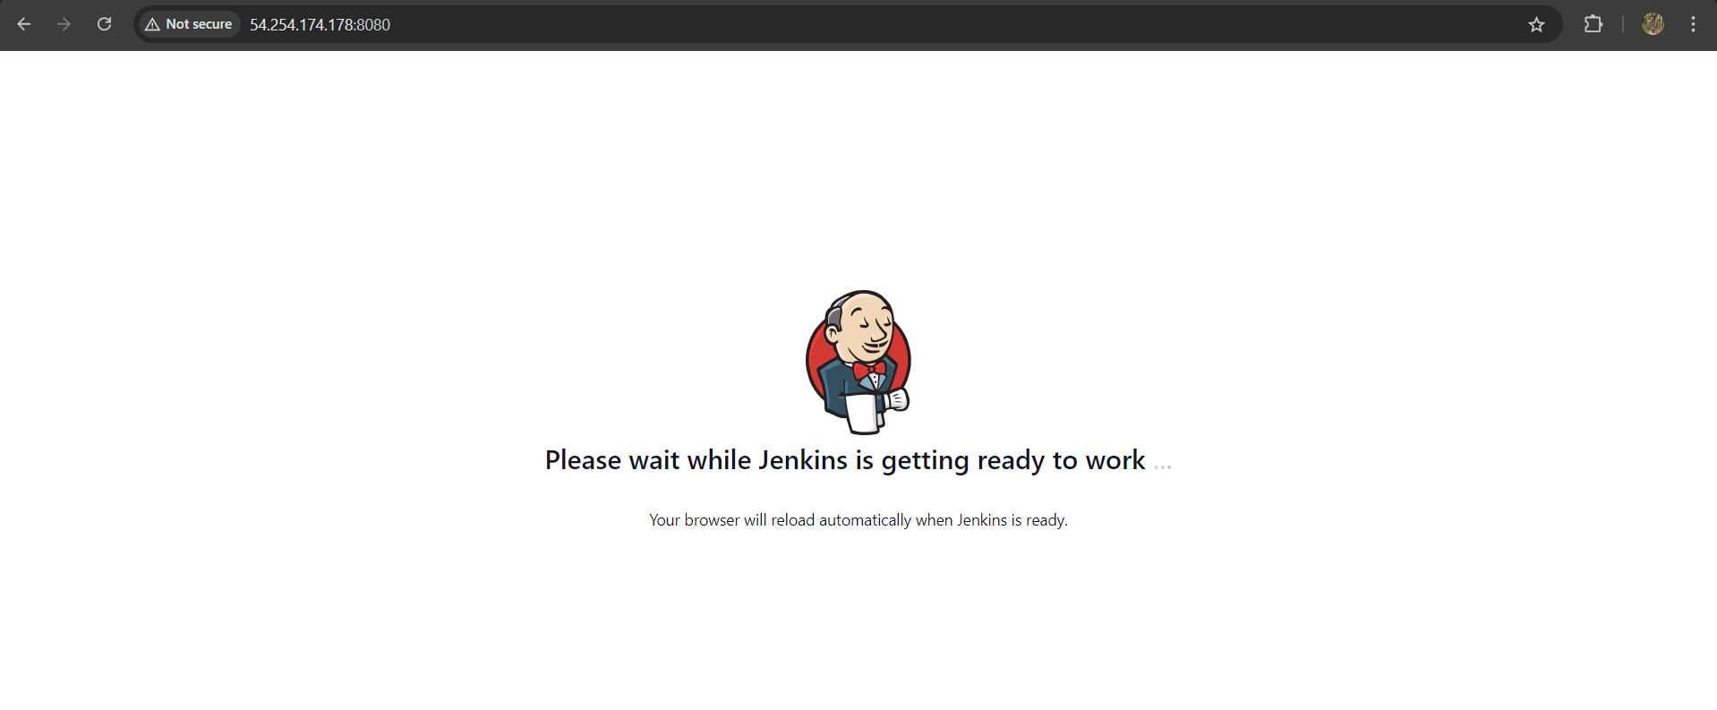

IP-2:

